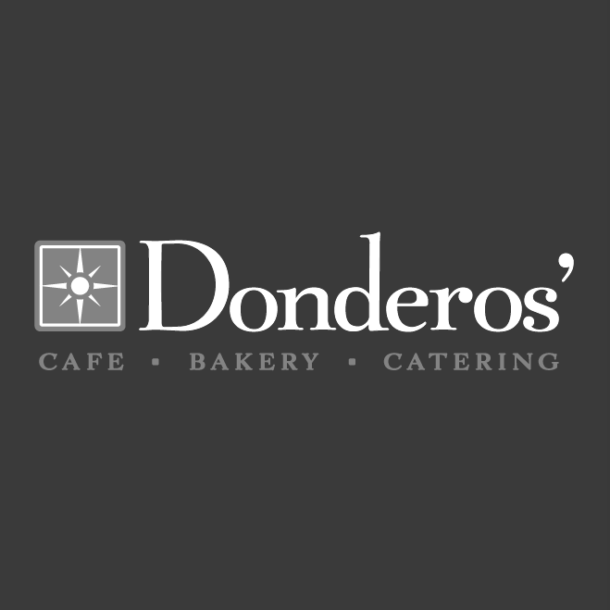

**Hot Italian** **$7.25**

Ham, salami, swiss, red onions, spinach, and Italian mayo on a French roll

V+ **Falafel Wrap** **$7.25**

House-made falafel, hummus, cacik, red onion, and feta cheese on pita

**Add a side for $2.25: house-made chips, cup of soup, or chickpea salad**

+ **Egg Plate** **$5.50**

Two eggs SCRAMBLED OR FRIED TO ORDER** served with toast, jam, and potatoes

+ **Breakfast Sandwich** **$5.50**

Scrambled Eggs, spinach, and cheese served on a warm croissant

V **granola & yogurt** **$3.25**

A cup of Our housemade granola with plain yogurt

**Crab Cake** **$8.00**

Tim’s crabcake, spinach, tomatoes, red onion, and remoulade on a butter bun

+ **Chicken Salad Wrap $7.25**

4oz house-made chicken salad, spinach, tomatoes, and mozzarella cheese on pita

+ **Tuscan Chicken** **$7.25**

Herbed chicken, spinach, mozzarella, tomatoes, red onions, and Dijon mustard

V+ **Hummus & Veggie** **$6.50**

Roasted veggies, hummus, mozzarella, served on pita

V+ **Black Bean Burger** **$7.25**

House- made black bean burger, spinach, tomato, red onion, and mango chutney, on a butter bun

**Top off any breakfast item with bacon, roasted veggies, sausage, and/or fried green tomatoes.**

First topping: **$1.75** Additional topping: **$1.25** Crab Cake: **$3.50**

**Warm Sandwiches & Wraps:**

**DK Staples:**

V+ **Burrito** **$6.50**

Fried potatoes, scrambled eggs, cheese encased in a toasted tortilla

+ **Skillet** **$6.50**

Fried potatoes and scrambled eggs covered in cheese served with our house made salsa

V+ **DK Scramble** **$6.50**

Eggs scrambled with onions, bell peppers, cilantro, and tomatoes served with a side of toast, jam, and potatoes

V+ **Protein Bowl** **$9.50**

Whole grain quinoa & wild rice tossed in citrus vinaigrette, topped with greens, roasted veggies, toasted almonds, & a fried egg, COOKED TO ORDER**

V **Noodle Bowl** **$8.50**

Our cold Szechuan noodles topped with chicken or tofu

**Fried green tomatoes** **$7.25**

Fried green tomatoes, goat cheese, green onion, and roasted red pepper sauce on ciabatta

ADD A FRIED EGG, COOKED TO ORDER** +$1

**Pimento Cheese** **$6.50**

Our take on the time-honored southern classic; served on toasted flatbread (or whole wheat) with a pickle

½ & ½ : **$6.50**

**Pick two:**

* ½ sandwich: chicken salad, pimento cheese, or roasted veggie and hummus
* Cup of soup
* Cup of chick pea salad

Kiddos: **$3.75**

* Scrambled egg and toast V+
* Ham or Turkey on whole wheat +
* Peanut Butter and jam on whole wheat V+
* Egg and cheese quesadilla V+
* Grilled cheese on whole wheat +
* ½ Chicken salad on flatbread+

Entree Salad: **$5.00**

* Add a scoop of pimento cheese **$1.25**
* Add a scoop of chicken salad **$2.50**

Soups:

* Tomato Bisque
* Soup du Jour V

**See our specials board**

**Cup: $2.75 Bowl: $4.00**



+: Gluten free upon request

(gf FLATBREAD +$1)

V: Vegan upon request

=

à la carte

Bacon (2) **$2.50**

Sausage (2) **$2.75**

Potatoes **$2.00**

Soup cup/bowl **$2.75/$4.00**

Fried green tomatoes (2) **$2.50**

Crabcake **$4.00**

** Warning: consuming raw or undercooked meats, poultry, seafood, shellfish, or eggs may increase your risk of foodborne illnesses